REKINDLE YOUR FIRST LOVE

At the end of his letter to the Ephesians, the apostle Paul commended that church for their undying love.
A generation later in Revelation 2 when John writes to the church in Ephesus he tells them that they have lost their first love. Many pastors – because of the demands of ministry, the painful experience of being hurt and even betrayed by congregational members and having to deal with so much conflict – have lost their first love. In addition, all of us need time to get away for spiritual, emotional, and relational refreshment and renewal. We invite you – we urge you to come and join us for a day of inspiration and encouragement.
Come to rekindle and regain your first love.

This gathering will take place on Wednesday, May 1, 2019 at Trinity Lutheran Church, 276 Cleveland Street,
in Warrenton, Virginia and will be a full day of spiritual and emotional renewal for pastors. It will include presentations, processing, prayer, fellowship, worship, determining next steps, and personal ministry time.

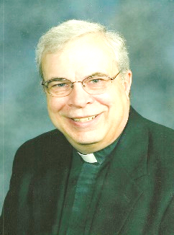 |  | NALC Pastor Tim Hubert will talk about “Rekindling Your First Love for Christ.” Describing himself as “someone who continually needs to return to Jesus,” Tim has been a pastor for over thirty-five years. During the last dozen years he has served as an intentional interim pastor for severely conflicted congregations. He tells his interim congregations to look for a pastor who loves Jesus first and them second. Pastor Tim says, “This is a time to experience His love through prayer, song, and conversation.  This is a time for the Holy Spirit to heal our souls so we can continue to be a blessing to others.”
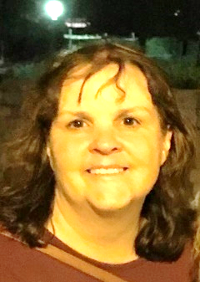 |  | NALC/LCMC Pastor Wendy Berthelsen will speak on “Rekindling Your First Love for the Church as the Body of Christ.” Wendy has served through the highs and lows of ministry for thirty-six years, thirteen of those years as an ordained pastor. She has worked with her pastor-husband at Hope Lutheran Church in Cedar Hill, Texas, and currently serves as interim pastor for the Lutheran Church of the Risen Lord in Odessa, Texas. Wendy is co-founder of Call Inc., a non-profit teaching mission dedicated to mobilizing ordinary people “called” by Jesus to “incorporate” His call into all of life.
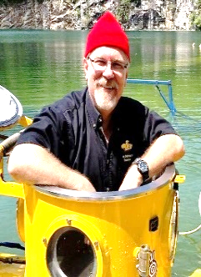 |  | ELCA Pastor Brian Hughes will address “Rekindling Your First Love for Mission and Ministry as the Work of Christ in the World.” Brian has served churches in several places, including for the last sixteen years in Columbia, Maryland. He will lead us  in exploring a tool known as “the landscape of life” as we delve into how each of us has been uniquely shaped to hear the Gospel and what Jesus wants us to do with it.  With an earned doctorate in Family Systems, Brian loves to ride his Harley and explore the ocean depths in his personal submarine.
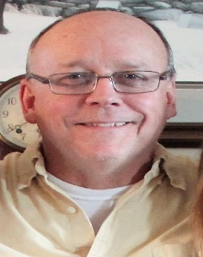 |  | NALC/LCMC Pastor Craig Moorman will help lead us in identifying the personal takeaways from our time together and develop them into a realistic plan for implementation. It is Craig’s hope that each of us will leave here renewed--rekindled and on fire--and re-establish our first love for Jesus Christ, His Church, and the Mission of Christ through specific action items.  Craig has served congregations in Maryland for thirty-two years both as a pastor and mission developer. In fact, he currently serves in both capacities – as a mission developer in Mt. Airy, Maryland, and as an interim pastor in Dundalk, Maryland. He was also part of the start-up Mission Team for the NALC.

