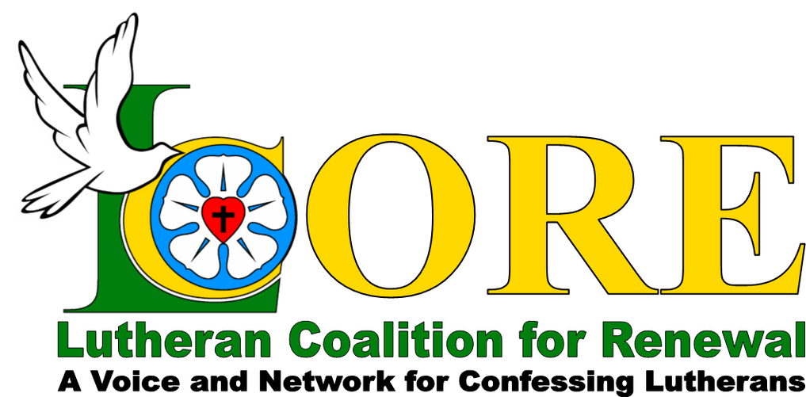
REKINDLE YOUR
FIRST LOVE

A Day of Inspiration, Encouragement, and Renewal for Pastors
Wednesday, May 1, 2019
Begins at 9 AM and includes lunch and dinner
Evening Options Include:
fellowship, personal ministry time,
silent or small group prayer

Trinity Lutheran Church
276 Cleveland Street
Warrenton, Virginia 20186

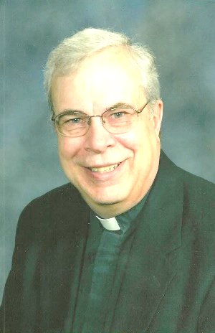 | 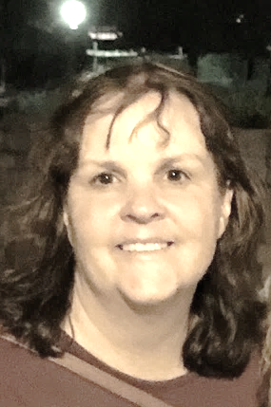 |  | 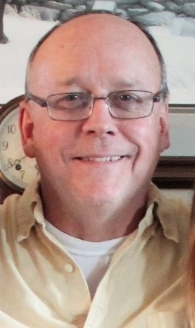
Pastor Tim Hubert (NALC) | Pastor Wendy Berthelsen (NALC/LCMC) | Pastor Brian Hughes  (ELCA) | Pastor Craig  Moorman  (NALC/LCMC)
“Rekindling Your  First Love  for Christ” | “Rekindling Your  First Love  for the Church as  the Body of Christ” | “Rekindling Your First Love for Mission and Ministry as the Work of Christ in the World” | “Next Steps:  From Rekindling to  Re-establishing the Fire  of Our First Love”
Blocks of Rooms Available
Holiday Inn Express and Suites
540-341-3461
$115.00 per night plus tax
Code: LGC

Baymont Inn and Suites
540-349-8900
$79.99 per night plus tax
Code: Rekindle Event

Call for Rates/No Block Available
Hampton Inn
540-349-4200
Registration: $40
Includes Lunch, Dinner, and Snacks

Ways to register –
- Call Lutheran CORE at
1-888-810–4180
- Email Lutheran CORE at lcorewebmail@gmail.com
- Send a check made payable to

Lutheran CORE
P. O. Box 1741, Wausau, WI 54402-1741

Be sure to indicate it is for Rekindle Event.

